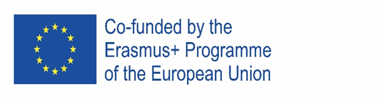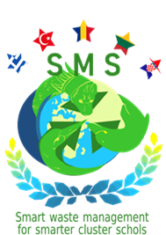

Erasmus+ project “SMART WASTE MANAGEMENT FOR SMARTER CLUSTER SCHOOLS”- 2020-1-RO01-KA229-079971

IMPACT MAP

- THE IMPACT ON THE TEACHING STAFF

- teachers will be more involved in designing, implementing and monitoring a waste management strategy / plan;
- they will develop health and economic partnerships;
- they will know many activities that can be carried out to improve smart waste management system in schools;
- they will improve knowledge of health, well-being and environmental protection;
- they will acquire knowledge how to activate cluster scholar community and develop the leadership skills;
- they will develop team- working skills;
- they will gain interpersonal / intercultural communication;
- they will improve linguistic competences and international relationship;
- they will the improve the use of digital tools;
- greater involvement in the school with Erasmus, eTwinning projects or projects at the national level;
- the teaching process will be more flexible and innovative;
- improvement in the quality of our own teaching;
- improving the competences as educational tools creators;
- improvement of relationship between teacher and student;
- gaining the status of an international teacher, able to work in international teams;
- increasing the success at working place.

2. THE IMPACT ON THE STUDENTS

- students will be able to disseminate healthy experiences and habits for life in the school group, families, society;
- they will gain knowledge about health, well-being and environmental protection;
- they will develop key competences and independent life skills;
- they will increase responsible and active citizenship, including digital one;
- they will be more motivated, more open and respectful to the environment;
- they will increase emotional intelligence;
- they will develop team- working skills;
- they will improve communication in English;
- they will improve the use of digital tools;
- improvement of relationship between teacher and student;
- improvement of academic results;
- improving the level of participation at community level, as active citizen.

3. THE IMPACT ON THE FAMILIES

- the school-parent relationship will be improved (parents will be more involved in school life);
- habits of proper waste management and family health practices will be strengthened;
- they will gain knowledge about health, well-being and environmental protection;
- improvement in family- school centre relations;
- increased interest in the studies and life of their children;
- improving relationship inside a family;
- increasing the quality of life;
- improving level of participation at community level.

4. THE IMPACT ON THE SCHOOL

- schools will be stronger working in a network in which nodes play an active role;
- schools will be able to design and implement a smart waste collection and reuse strategy;
- the school will be more international and accessible for all learners;
- the school will become a more reliable partner of community;
- the partnership between schools and private/ public areas will be strengthened.
5. THE IMPACT ON THE COMMUNITY ACTORS

- the actors participating in the project will cooperate to create a solidary;
- they will develop their critical thinking;
- they will be oriented towards results and solutions;
- they will create a new educational networking at European level;
- they will rebuild the links between schools and other actors of community;
- they will make strong and close relationship;
- they will reinforce the international cooperation by global perspective;
- they will create the sense of global citizenship.

